# If/Else Statements

## Question: 1

Which of the following is an example of an if/else statement scenario?

If it is raining, bring an umbrella.

If it is cold out wear a coat. If it is raining, wear a hat.

If it is raining, bring an umbrella. If not, wear sunglasses.

If it is not cold out, don’t wear a coat.

## Question: 2

What is the limit of conditions that can be used in an if/else statement?

1

2

4

unlimited

## Question: 3

Which of the following if/else statements using a variable called ‘count’ are written correctly?

if count > 10():

forward(100)

else():

forward(50)

if count > 10:

forward(100)

else:

forward(50)

if (count) > 10:

forward(100)

else:

forward(50)

if count > 10:

forward(100)

else():

forward(50)

## Question: 4

What would be the radius of the circle output from the following code?

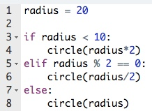

10 pixels

20 pixels

30 pixels

40 pixels

# If Statements

## Question: 1

Why do we use if statements?

To tell Tracy to stop our code if there’s an error

To have Tracy make decisions based on conditional statements

To tell Tracy to do something if we run our code

To have Tracy complete one function at a time

## Question: 2

If we write an if statement and the condition is false, what does Tracy do?

The code stops running

Tracy gives us an error

Tracy completes the indented code

Tracy skips the commands under the if statement

## Question: 3

How would we write an if statement where Tracy will put the pen down if a variable called count was positive?

if count >= 0:

pendown()

if count > 0():

pendown()

if count > 0:

pendown()

if count > 0:

pendown()

## Question: 4

Which comparison operator means ‘is not equal to’?

!=

==

=#

%

## Question: 5

If the following code was run, how far would Tracy move?

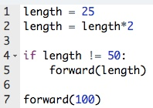

0 pixels

25 pixels

50 pixels

100 pixels